BUAN/OPRE 6398.003 Prescriptive Analytics

Homework 6

Team 6

Taeho Kim
Lin Li
Madhuri Kashyap
Manasa Venkatesh
Thomas Trieu
Yu-Min Wang

2.
1) By Greedy algorithm, we get the following minimal spanning tree. The minimal amount of cable in miles = 0.48+0.2+0.58+0.48+0.4+0.6+0.6+0.34+0.47 = 4.15 miles
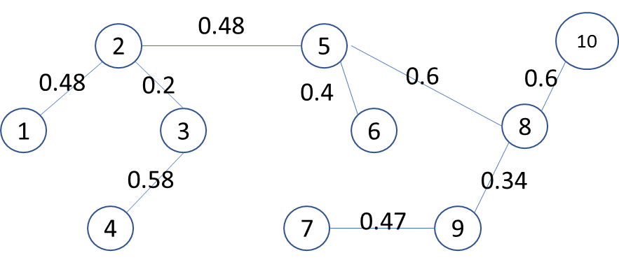

2) By Dijkstra’s algorithm, we get the following shortest routes from site 1 :

Site Shortest route Distance (miles)
-----------------------------------------------------------------------------
2 1-2 0.48
3 1-2-3 0.48+0.2= 0.68
4 1-4 0.7
5 1-2-5 0.48+0.48=0.96
6 1-2-5-6 0.48+0.48+0.4=1.36
7 1-4-7 0.7+0.7=1.4
8 1-2-5-8 0.48+0.48+0.6=1.56
9 1-4-7-9 0.7+0.7+0.47=1.87
10 1-2-5-10 0.48+0.48+1.18=2.14

3.
Using Ford-Fulkerson method, we get the maximum flow
= (5+10+7+11) –(0+6+0+11) = (9+4+7) – (4+0+0) = 16 (thousands of cubic feet per minute)

4.
1) Initial feasible solution by Northwest-corner method:

 | X | Y | Z | Supply
A | 11  40000 | 5 | 8 | 40,000
B | 8  50000 | 9  50000 | 12 | 100,000
C | 13 | 10  10000 | 7  70000 | 80,000
Demand | 90,000 | 60,000 | 70,000 | 220,000  220,000

2)
The current total cost = 11(40000)+8(50000)+ 9(50000)+10(10000)+7(70000)=1880000
Evaluation:
R1+K1 =11 R1=0 K1=11
R2+K1=8 R2=-3
R2+K2=9 K2=12
R3+K2=10 R3=-2
R3+K3=7 K3=9

A-Y: 5-(0+12)= -7
A-Z: 8-(0+9)= -1
B-Z: 12-(-3+9)= 6
C-X: 13-(-2+11) = 4
The current solution is not optimal because -7<0, -1<0. -7 is the minimum so we move 40000 units to A-Y because a “-“ sign appears in cell B-Y and A-X and min{40000, 50000} = 40000.The new solution is like below and Total Cost = 1880000 – 7(40000) = 1600000
 | X | Y | Z | Supply
A | 11 | 5  40000 | 8 | 40,000
B | 8  90000 | 9  10000 | 12 | 100,000
C | 13 | 10  10000 | 7  70000 | 80,000
Demand | 90,000 | 60,000 | 70,000 | 220,000  220,000

Evaluation :
R1 + K2 = 5 R1=0 K2=5
R2 + K1 = 8 K1=4
R2+ K2 = 9 R2=4
R3 + K2 = 10 R3=5
R3 + K3 = 7 K3=2

A-X: 11-(0+4) = 7
A-Z: 8-(0+2)= 6
B-Z: 12-(4+2)= 6
C-X: 13- (5+4) = 4

The current solution is optimal since all evaluations are positive or 0.

3)
The optimal shipping scheme is :

From To Quantity
-------------------------------------------
A Y 40000
B X 90000
B Y 10000
C Y 10000
C Z 70000

The minimum transportation cost is $1600000

